Estimate email

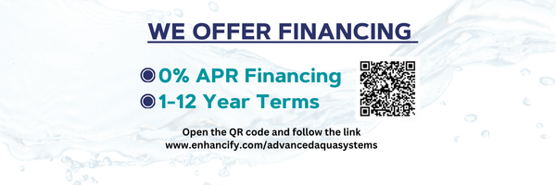
Hi {CustomerContact:FirstName}:
Here is the recommended water treatment system estimate we discussed for your home.
If you have questions or need to make changes to the estimate you can call or text me directly at 435-817-2600.
I look forward to working with you.
Chris Phillips
{Company:CompanyLogo}

{Company:Slogan}
View & Accept Estimate Online →
{Estimate:RateTable}
{Estimate:Pictures}
Thank You,
250 Red Cliffs Dr. #4B-224
St. George, UT 84790
{Company:Phone1}
{Company:Email1}
www.advancedaquasystems.com
www.drop.pro
Filtration Service email

Hi {Customer:Name},
This is a courtesy reminder to let you know that our records indicate your regularly scheduled filter service is due for your reverse osmosis water purification system.
In order to get the maximum benefits of your water purification system, we recommend following this service schedule based on your system brand, make & model.
Our records indicate service was last performed at
{Customer:StreetAddress}
{Customer:City}, {Customer:StateProv} {Customer:PostCode}
CALL NOW to schedule your appointment!
{Company:Phone1}
Thank You!
Amber Phillips
Advanced Aqua Systems
www.advancedaquasystems.com
{Company:Slogan}

